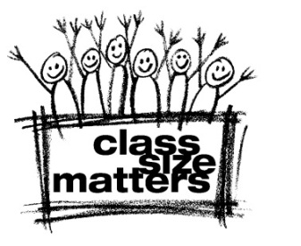
Class Size Matters
124 Waverly Place, NY, NY 10011
phone: 212- 674- 7320
www.classsizematters.org
email: info@classsizematters.org

To: jking@mail.nysed.gov
CC: DMWalcott@schools.nyc.gov, stacey.childress@gatesfoundation.org,
RegentsOffice@mail.nysed.gov, Eric.Schneiderman@ag.ny.gov, mc@carnegie.org,
speaker@assembly.state.ny.us; skelos@senate.state.ny.us, jdklein@senate.state.ny.us, nolanc@assembly.state.ny.us, flanagan@nysenate.gov

Subject: Violation of student privacy by State Education Dept.

Dear Commissioner King: As a parent, I was appalled to learn, as this Reuters article (http://goo.gl/OUVtb) confirms, that the NY State Education Department is planning to share the most private, confidential data of my child and all NYS public school students with a corporation called inBloom Inc., that will store this highly sensitive information on a vulnerable data cloud and disclose it to for-profit vendors to help them develop and market their products.

This data will include children’s personally identifiable information, including names, addresses, phone numbers, grades, test scores, detailed disciplinary records, health conditions, special education and economic status.

The company inBloom Inc. has already stated that it “cannot guarantee the security of the information stored…or that the information will not be intercepted when it is being transmitted.” All this is happening without parental notification or consent.
I hereby OPT my child’s data out of this plan, and demand that you do NOT disclose any of my child’s personally identifiable educational records with ANY third party including the Gates Foundation, inBloom, Inc. or ANY other private entity or corporation.

I DO NOT give my consent. Instead, I urge you to hold public hearings in NYC and throughout the state to explain the purpose of this project, offer all New York parents the right to consent, and inform the public who will be legally and financially responsible if this highly sensitive data leaks out or is used in an unauthorized fashion.

I expect to hear back from you immediately as to whether you will honor my request to withhold my child’s private and confidential educational records.

If not, I will call your office until you do so. As a parent, I am outraged at your plan which not only violates every ethical standard and principle of moral decency, but also your commitment as the state’s highest educational official to protect my child from harm.

Yours, [Your Name and complete address] Parent [or legal guardian] of [your child’s name, grade and school]

